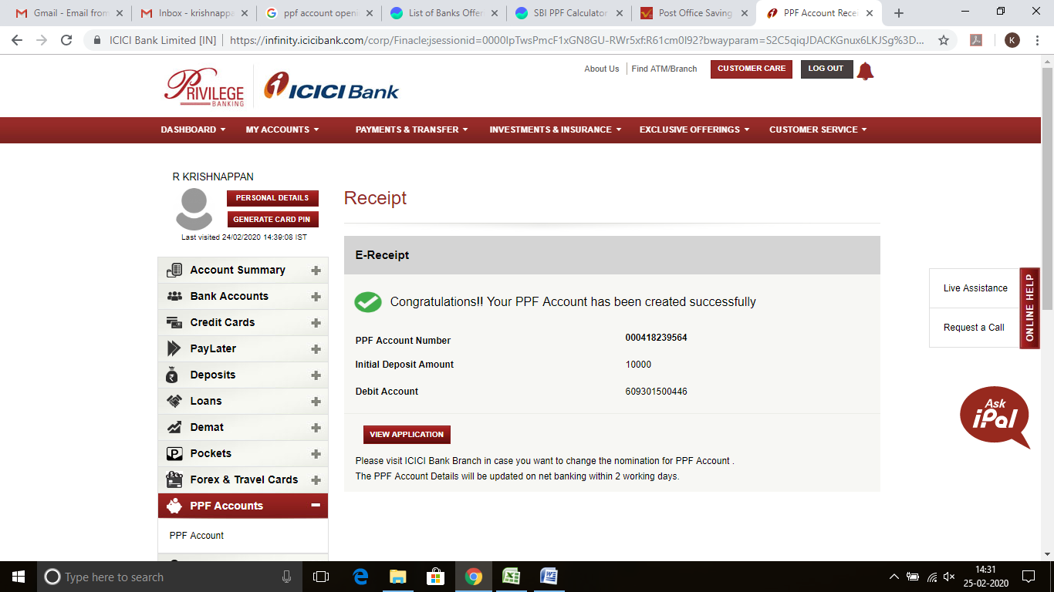

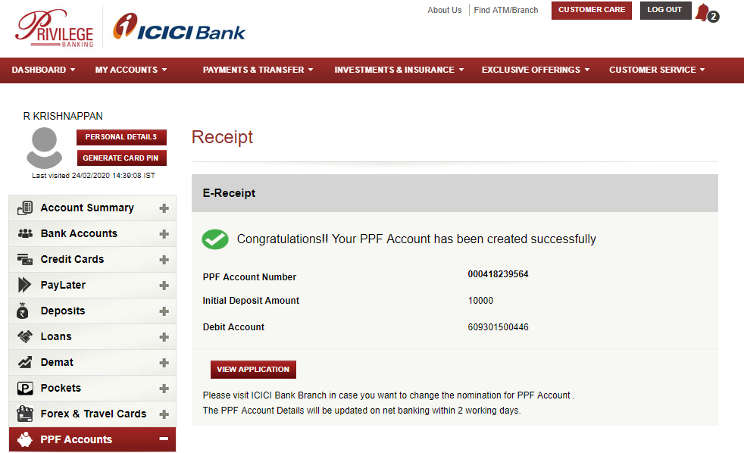

Screen Shot : 25-FEB-2020 14:31 PM Intellect Design Arena Limited, Siruseri, Chennai

|  |  |  |
| --- | --- | --- |
| PPF Account Number | : | **000418239564** |
| Initial Deposit Amount | : | 10000 |
| Debit Account | : | 609301500446 |